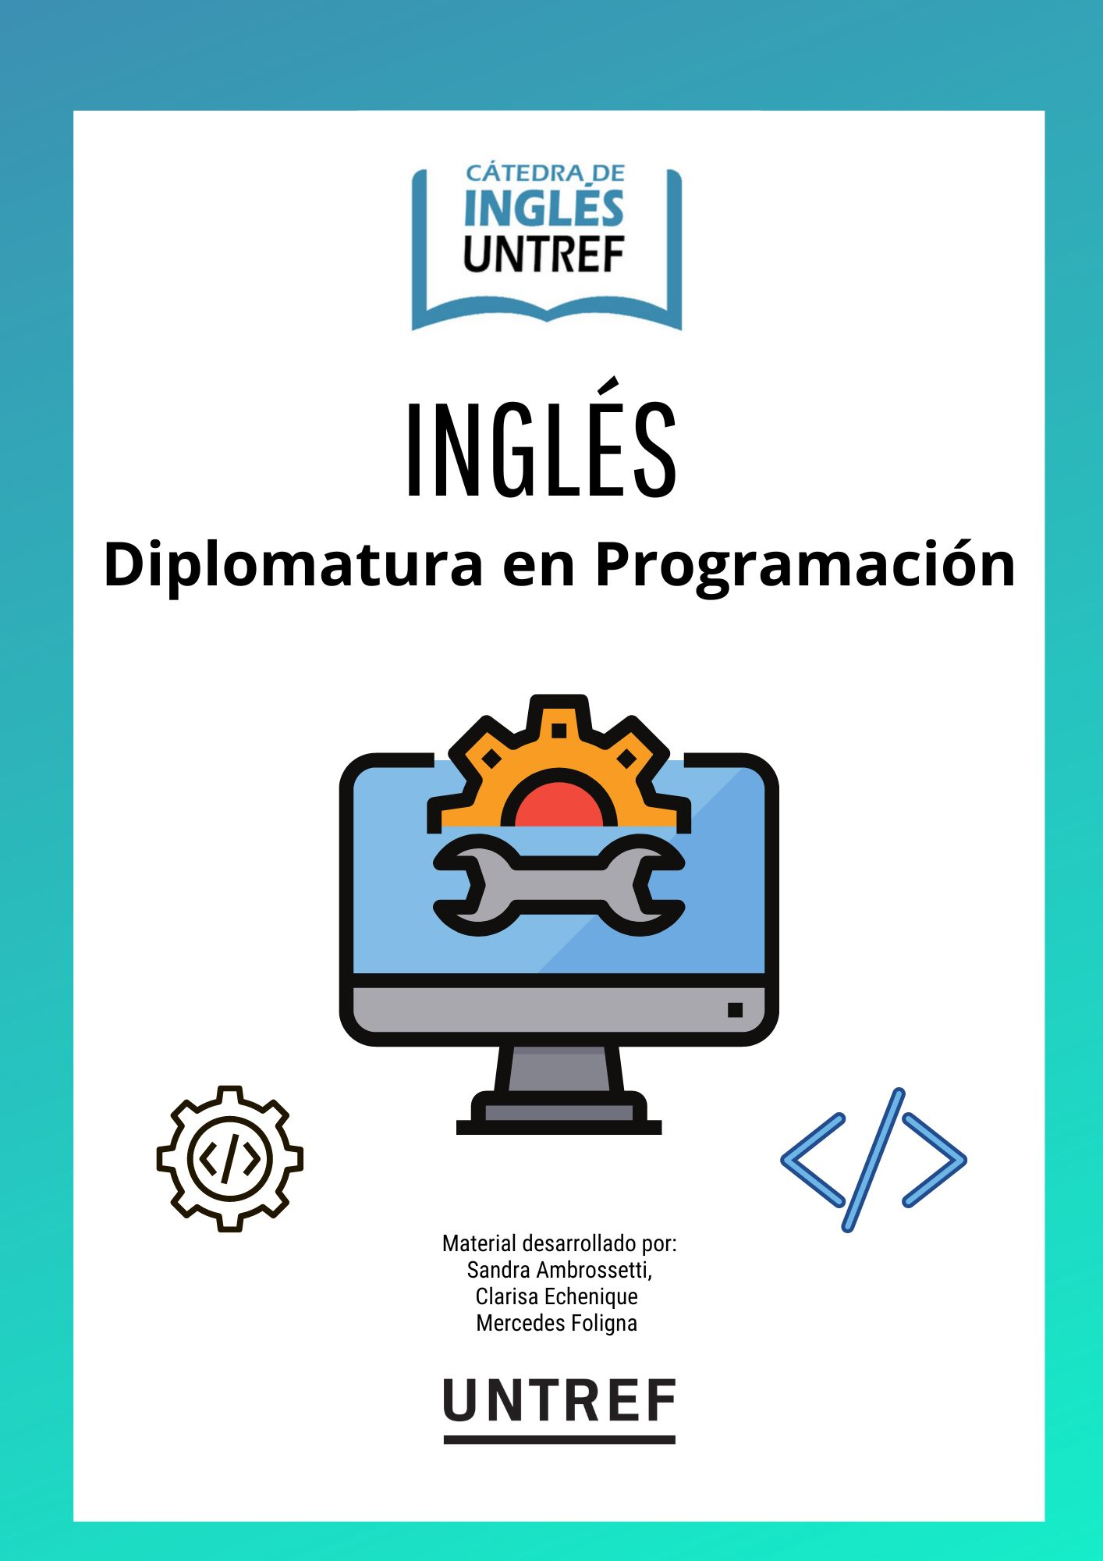

|  |
| --- |
| [Website developer Glossary](https://docs.google.com/document/d/18mRt615ShBfnyy25f9kWro4SfXTBuN676V4BH4JReX4/edit?usp=sharing) |

HOLAAAAAA SOY GABIIIII

|  |
| --- |
| **REFERENCIAS** |
| Ballou, Glen. Handbook for Sound Engineers. Fourth Edition. (2008) Jeff Szymanski, "Acoustical Treatment for Indoor Areas". Disponible en:<https://drive.google.com/file/d/1d7rmCNGXqmPxTkJ8H3mXjnyFZArpJ-7Q/view> Recuperado el: 17/7/2022. |
| Ballou, Glen. Handbook for Sound Engineers. Fourth Edition. (2008) Jeff Szymanski, "Acoustical Treatment for Indoor Areas: Site Noise Survey ". Disponible en:<https://drive.google.com/file/d/1d7rmCNGXqmPxTkJ8H3mXjnyFZArpJ-7Q/view> Recuperado el: 17/7/2022. |
| Enciclopedia Wikipedia. Entrada correspondiente a “Allies of World War I”. Disponible en:<https://en.wikipedia.org/wiki/Allies_of_World_War_I> Recuperado el 16/8/2021 |
| Enciclopedia Wikipedia. Entrada correspondiente a “Prvá svetová vojna”. Disponible en:<https://sk.wikipedia.org/wiki/Prv%C3%A1_svetov%C3%A1_vojna> Recuperado el 16/8/2021 |
| Enciclopedia Wikipedia. Entrada correspondiente a "Computer". Disponible en:<https://en.wikipedia.org/wiki/Computer> Recuperado el 17/7/2022. |
| Enciclopedia Wikipedia. Entrada correspondiente a "Noise Curve". Disponible en:<https://en.wikipedia.org/wiki/Noise_curve> Recuperado el 17/7/2022. |
| Famous People Lessons. English lesson on Maria Montessori. Disponible en:<https://famouspeoplelessons.com/m/maria_montessori.html> Recuperado el: 21/8/2021 |
| Kamlet, Rick. "Acoustics and Sound Systems in Architectural Design" (2005) Disponible en:<https://sonotone.in/images/technical-library/Sound_In_Architectural_Design.pdf> |
| My English Pages. “A brief history of the Vikings” Disponible en:<https://www.myenglishpages.com/english/reading-brief-history-of-vikings.php> Recuperado el: 24/9/2021 |
| My English Pages. “Filmmaking” Disponible en:<https://www.myenglishpages.com/english/reading-filmmaking.php> Recuperado el: 5/8/2021 |
| My English Pages. “Robots” Disponible en:<https://www.myenglishpages.com/english/reading-robots.php> Recuperado el: 17/7/2022 |
| My English Pages. “Technology” Disponible en:<https://www.myenglishpages.com/english/reading-technology.php> Recuperado el: 17/7/2022 |
| My English Pages. “The Digital Divide” Disponible en:<https://www.myenglishpages.com/english/reading-digital-divide.php> Recuperado el: 17/7/2022 |
| My English Pages. “The Wall of China” Disponible en:<https://www.myenglishpages.com/english/reading_wall_of_china.php> Recuperado el: 5/8/2021 |
| My English Pages. “The World Wide Web” Disponible en:<https://www.myenglishpages.com/english/reading-world-wide-web.php> Recuperado el: 17/7/2022 |
| My English Pages.”7 ways to protect the environment” Disponible en:<https://www.myenglishpages.com/english/reading-7-ways-to-protect-the-environment.php> Recuperado el: 31/8/2021 |
| My English Pages “Brain Drain” Disponible en:<https://www.myenglishpages.com/english/reading_brain_drain.php> Recuperado el: 2/9/2021 |
| My English Pages “What is Information Technology?” Disponible en:<https://www.myenglishpages.com/english/reading_science.php> Recuperado el: 17/7/2022 |
| National Geographic Learning. “The first year of life” Disponible en:<https://www.ngllife.com/first-year-life-0> Recuperado el: 23/8/2021 |
| National Geographic Learning. “A long and healthy life?” Disponible en:<https://www.ngllife.com/long-and-healthy-life> Recuperado el: 4/9/2021 |
| Pierce, Allan D. *Acoustics. An Introduction to Its Physical Principles and Applications*. (2019) "The Wave Theory of Sound" |
| Salem, Mohamed “Globalization” in World Economy - Citado en: Guía N°7 - ROMERO Valeria Abigail Disponible en:<https://docer.com.ar/doc/ns8cn50> Recuperado el: 31/8/2021 |
| Sievenpiper, John Et. Al. (2018) “Nutrition Therapy" in Canadian Journal of Diabetes Year 2018 Vol 42 Page 564. Disponible en:<https://guidelines.diabetes.ca/docs/cpg/Ch11-Nutrition-Therapy.pdf> Recuperado el 21/8/2021 |
| The Washington Post (2005) "McDonald's Makes Ronald a Health Ambassador." Disponible en:<https://www.washingtonpost.com/wp-dyn/articles/A43011-2005Jan27.html> Recuperado el 20/8/2021 |
| UN Women (2020) "Violence against women and girls: the shadow pandemic" Disponible en:<https://www.unwomen.org/en/news/stories/2020/4/statement-ed-phumzile-violence-against-women-during-pandemic> Recuperado el 20/8/2021 |
| Voice Of America. (2021) South Africa to Begin Testing COVID-19 Vaccines Before Launching Program. Disponible en:<https://www.voanews.com/a/covid-19-pandemic_south-africa-begin-testing-covid-19-vaccines-launching-program/6201495.html> Recuperado el 20/8/2021 |
| Voice Of America. (2019) "Chinese Citizens Express Concern Over the Abuse of Facial Recognition Technology". Disponible en:<https://www.voanews.com/a/east-asia-pacific_chinese-citizens-express-concern-over-abuse-facial-recognition-technology/6180397.html> Recuperado el 17/7/2022 |